**Read the following description concerning network security, and then answer subquestion**

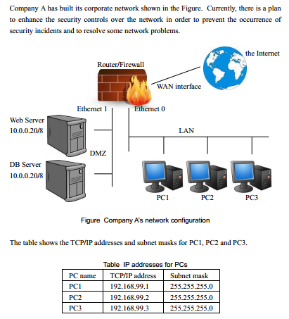

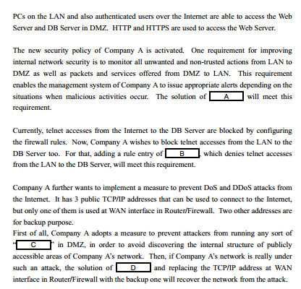

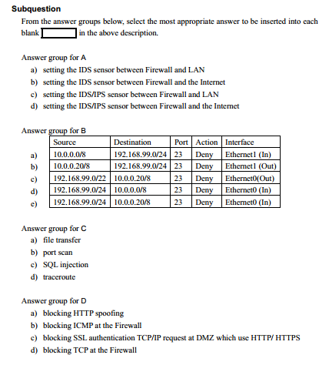

**Read the following description of DNS (Domain Name System), and then answer the**

**Sub questions 1 and 2.**

In a certain enterprise, each computer in the in-house network is controlled by using a domain name. The configuration of the network in this enterprise is shown below.

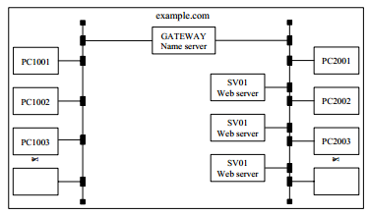

Correspondence between the domain name and the IP address of each computer is as shown in the table below.

Table Correspondence between domain names and IP addresses

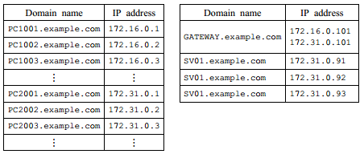

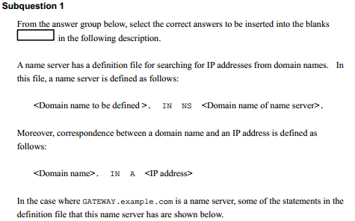

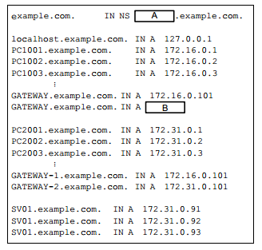

**Answer group:**

a) 127.0.0.1 b) 172.31.0.91 c) 172.31.0.101 (B)

d) GATEWAY (A) e) localhost f) SV01

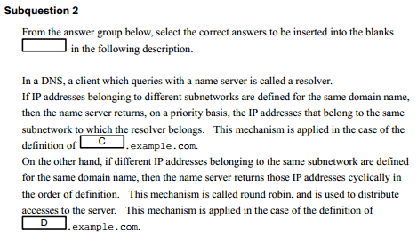

**Answer group:**

a) GATEWAY-1 b) GATEWAY-2 c) GATEWAY (C )

d) localhost e) SV01 (D)

**Read the following description of a communication network, and then answer**

**Sub questions 1 through 5.**

Figure 1 depicts the connection of the servers and PCs. Company A is given the IP gateway 199.141.27.129/26.

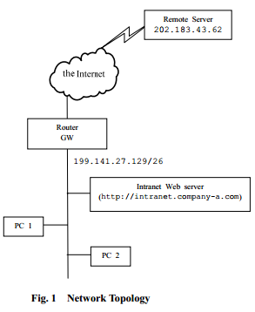

**Sub question 1**

What is the subnet mask that must be used by Company A?

Answer group:

a) 255.255.0.0 b) 255.255.254.0 c) 255.255.255.0

d) 255.255.255.128 e) 255.255.255.192 f) 255.255.255.224

g) 255.255.255.240 h) 255.255.255.252

**Subquestion 2**

What is the subnet IP address that must be used by Company A?

Answer group:

a) 199.141.0.0 b) 199.141.26.0 c) 199.141.27.0

d) 199.141.27.128 e) 199.141.27.192 f) 199.141.27.224

g) 199.141.27.240 h) 199.141.27.252

**Sub question 3**

What is the possible IP address for the PC1 and PC2?

**Answer group:**

a) 199.141.27.0, 199.141.27.112

b) 199.141.27.112, 199.141.27.150

c) 199.141.27.150, 199.141.27.168

d) 199.141.27.168, 199.141.27.200

**Sub question 4**

Users on network 199.141.27.0/26 are complaining that they cannot access the cooperate intranet server at intranet.company-a.com. In troubleshooting this problem, you find that you able to telnet a workstation (or PC.) on this network to the internal web server via its IP address. What is the likely cause of this problem?

**Answer group:**

a) DNS failure.

b) FTP failure.

c) SNMP failure.

d) TCP/IP failure.

**Sub question 5**

You are the network administrator of the Company A. You receive a call from a user who is unable to reach a server at a remote site. After further review, you discover the following information:

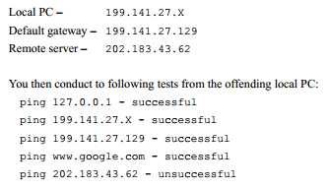

Which of the following problems would create the test results listed above?

**Answer group:**

a) Local NIC not functioning.

b) Local physical layer problem.

c) Remote physical layer problem.

d) TCP/IP not correctly installed.